## **Student Management System**

## **Introduction:**

The Student Management System, implemented using Python Django, is a robust web application designed to streamline the management of student and staff information, emphasizing attendance tracking and administrative efficiency. Divided into three key components – Student, Staff, and Admin Panel – the project provides a holistic solution for educational institutions. On the Student side, the application offers a user-friendly interface enabling students to view and update their profiles seamlessly. Additionally, students have access to their attendance records for each enrolled subject, allowing them to monitor their academic progress. The system facilitates leave applications, empowering students to request leave days and track their leave history. Notifications from the college administration keep students informed, and a feedback mechanism allows them to communicate with administrators.

The Staff Panel caters to teachers and staff members, offering features such as result management, attendance tracking, leave applications, and communication through notifications and feedback. Staff members can efficiently manage and input results for each student, take attendance for subjects they are responsible for, and apply for leave when necessary. The system ensures that administrative approvals are in place for staff leave applications, adding an extra layer of control.

The Admin Panel serves as the nerve center of the system, empowering administrators to manage courses, subjects, sessions, staff, and students. The initial setup involves configuring courses, subjects, and sessions, providing a foundational structure for the entire system. Staff records, representing teachers, are managed with details like name, email address, gender, password, image, and course information.

**Student Panel Features:**

***Profile Management:***

* Students have the ability to view and update their personal profiles.
* Details such as name, contact information, and address can be modified for accuracy.
* This feature provides students with control over their individual information.

## ***Attendance Records:***

* The system enables students to access detailed attendance records for each enrolled subject.
* A graphical representation may be used to display attendance percentages, aiding students in tracking their academic attendance.
* A dedicated section for leave history that allows students to view their complete leave history.
* This feature provides transparency regarding approved and rejected leave applications, helping students keep track of their attendance-related activities

## ***Leave Application:***

* Students can apply for leave directly through the system.
* The application includes necessary details such as leave dates and messages to provide context for the leave request.
* Submitted leave applications are then routed to the admin for approval..

## ***Notifications:***

* The system delivers notifications to students regarding important announcements, events, or changes from the college administration.
* Instant updates ensure that students are well-informed about any relevant information.

## 

## ***Feedback Mechanism:***

* Students can provide feedback to the administrators, creating a channel for communication.
* This feature allows students to express their opinions, share concerns, or suggest improvements within the educational framework.

## ***User-Friendly Responsive Design:***

* The web application incorporates a responsive design to ensure a seamless user experience across various devices.
* Whether accessed on a desktop, tablet, or smartphone, students can interact with the system effortlessly.
* The student panel is designed with a user-friendly interface, making navigation intuitive.
* Clear and concise options facilitate ease of use, ensuring that students can efficiently access and utilize the available features.

## ***Security Measures:***

* Security features are implemented to safeguard student data and maintain confidentiality.
* Authentication mechanisms, encrypted connections, and secure data storage contribute to the overall security of the student panel.

## ***User Assistance:***

* User assistant help documentation or tooltips may be integrated to assist students in understanding how to navigate and use different features.
* This ensures that students can make the most of the system without encountering difficulties.

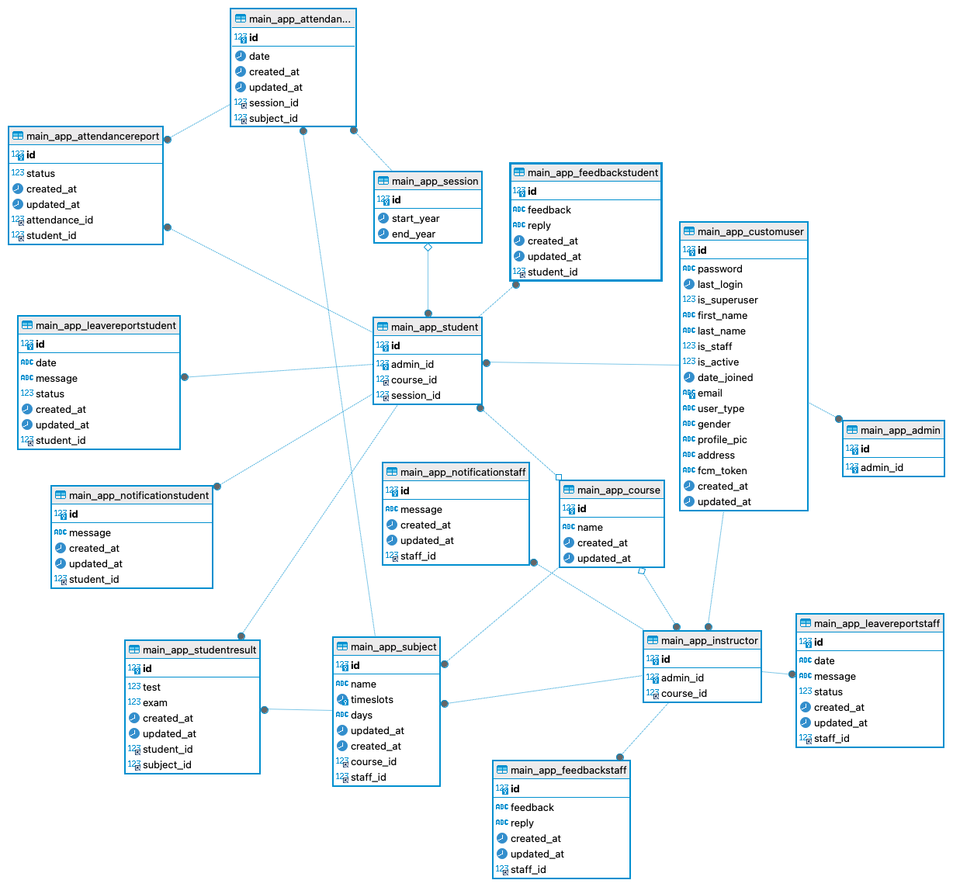

## **Staff Panel Features:**

## ***Result Management:***

* Staff members, representing teachers, can efficiently manage and input results for each student under their responsibility.
* Results are securely stored and can only be accessed by the respective staff member and administrators..
* This ensures the confidentiality and privacy of student academic information.

## ***Attendance Tracking:***

* Staff members have the capability to take and view attendance for the students enrolled in the subjects they teach.
* The attendance system allows staff to mark students as present or absent during specific sessions.
* Graphical representations can offer insights into student attendance, aiding staff in making informed decisions.
* The system may provide analytics tools for staff to analyze attendance patterns and trends.

## ***Leave Application:***

* Staff members can apply for leave directly through the system, specifying details such as leave dates and providing relevant messages.
* Leave applications are submitted to the admin for approval, ensuring a systematic process for staff leave management.

## ***Leave Approval Process:***

* The system includes an administrative approval process for staff leave applications.
* Admins review and approve or reject leave requests, maintaining control over staff attendance and ensuring adequate coverage.

## ***Notifications:***

* The staff panel receives notifications about important announcements, events, or changes from the college administration.
* Instant notifications keep staff members informed and engaged with pertinent information.

## 

## 

## ***Feedback Mechanism:***

* Staff members can provide feedback to the administrators, establishing a communication channel.
* This feature allows staff to share insights, express concerns, or make suggestions for continuous improvement.

## ***User-Friendly Responsive Design:***

* The staff panel is designed with a user-friendly interface to facilitate easy navigation and efficient use of available features.
* Clear options and intuitive design contribute to a positive user experience.
* The web application incorporates a responsive design to ensure a seamless user experience across various devices.
* Staff members can interact with the system effortlessly, whether accessed on a desktop, tablet, or smartphone.

## ***Security Measures:***

* Robust security features are implemented to protect sensitive data and maintain the integrity of academic information.
* Authentication mechanisms and encrypted connections contribute to the overall security of the staff panel.

## **Admin Panel Features:**

## ***Course and Subject Management:***

* Admins have the capability to manage courses, defining the academic structure of the institution.
* Course details, including names, descriptions, and dates, can be configured to align with the educational offerings.
* The admin panel facilitates the management of subjects, allowing admins to define the subjects offered within each course.
* Admins can configure subject details, providing a comprehensive overview of the academic curriculum.

## ***Session Management:***

* Admins are responsible for managing academic sessions, establishing the timelines for courses and subjects.
* Session details, including start and end dates, are configured to ensure a well-structured academic calendar.

## ***Staff Management:***

* Admins can manage staff records, specifically teachers and other staff members.
* Details such as names, email addresses, gender, passwords, images, and assigned courses can be administered through this feature.

## ***Student Management:***

* Admins oversee the registration of students, handling personal and login details during the initial setup.
* This section plays a crucial role in maintaining an organized student database within the system.
* Admins have access to attendance, ensuring a centralized view of student and staff attendance records.
* The admin panel may include tools for generating attendance reports and analytics.

## 

## 

## 

## ***Notification System:***

* The admin panel serves as the hub for sending important notifications to both staff and students.
* Admins can disseminate information, announcements, or updates efficiently through this centralized system.

## ***Leave Approval System:***

* Admins play a pivotal role in the approval process for staff leave applications.
* Leave requests are reviewed, and admins have the authority to approve or reject them, maintaining control over attendance.

## ***User Feedback Handling:***

* The admin panel incorporates a mechanism for handling feedback from both staff and students.
* Admins can review and respond to feedback, fostering effective communication and addressing concerns.

## ***Security and Access Control:***

* Robust security measures are implemented within the admin panel to safeguard sensitive data.
* Access controls ensure that only authorized personnel can access and modify critical information.
* The admin panel allows the user for configuration of system settings, ensuring adaptability to the institution's specific needs.
* This includes adjusting parameters related to user roles, notifications, and system behavior.

## 

## 

## ***Data Analytics and Reporting:***

* Admins may have access to data analytics tools for generating reports on various aspects of the academic and administrative processes.
* Analytics can provide insights into attendance trends, academic performance, and overall system utilization.

## **Technology Stack:**

## ***Python:***

* The core programming language used for developing the backend logic and functionalities of the Student Management System.
* Known for its readability and versatility, Python provides a robust foundation for building web applications.

## ***Django Framework:***

* Django serves as the primary web framework, facilitating the rapid development of secure and scalable web applications.
* Its built-in features, such as an ORM (Object-Relational Mapping) system and an admin panel, streamline development and administration.

## ***MySQL Database:***

* MySQL is employed as the relational database management system to store and manage structured data efficiently.
* It ensures data integrity, scalability, and provides SQL querying capabilities for seamless data retrieval.

## 

## 

## ***Bootstrap:***

* Bootstrap is utilized for front-end development, providing a responsive and mobile-first design approach.
* Its pre-designed components and grid system enhance the visual appeal and user experience of the web application.

## ***HTML:***

* HTML forms the structural foundation of web pages, defining the layout and content structure.
* Used to create a standardized structure for presenting information on the user interface.

## ***CSS:***

* CSS is employed to enhance the visual presentation and styling of HTML elements.
* It ensures consistency in design across different pages and devices, contributing to a cohesive user interface.

## ***JavaScript:***

* JavaScript adds interactivity and dynamic behavior to the web application.
* Used for client-side scripting, it enables features like form validation, asynchronous data fetching, and interactive user interfaces.

## ***AWS:***

* AWS is chosen as the cloud computing platform for deployment, ensuring scalability, reliability, and accessibility.
* Specific AWS services such as EC2 (Elastic Compute Cloud) and RDS (Relational Database Service) are employed for hosting and managing application resources.

## ***Git:***

* Git is utilized for version control, allowing collaborative development and tracking changes in the source code.
* Code repositories, such as AWS CodeCommit, enhance code management and deployment processes.

## ***API Gateway:***

* An API Gateway is implemented for creating, publishing, and managing APIs, facilitating the integration of HTTP URIs and ensuring secure communication between different components.
* Including security measures, encryption protocols (HTTPS), secure user authentication, and access controls, are implemented to protect sensitive data and ensure the confidentiality of user information.

**Application Screenshot**

**<ADD screenshots>**

## **Conclusion:**

The Student Management System, powered by Python Django, is a sophisticated web application designed for seamless student-staff interaction and efficient administrative processes. With a three-tiered structure comprising Student, Staff, and Admin Panels, the system optimally caters to diverse user roles within an educational institution. On the Student side, the interface allows for easy profile viewing and updating, access to attendance records, leave applications, and communication through notifications and feedback. For Staff members, the system facilitates result management, subject-wise attendance tracking, leave applications with admin approval, and communication channels. The Admin Panel acts as the central control hub, overseeing course, subject, and session management, as well as staff and student administration. Employing Python Django, MySQL, Bootstrap, CSS, and HTML, the technology stack ensures a responsive and visually appealing interface. Deployed on AWS, the system is characterized by scalability and accessibility. In summary, the Student Management System provides a comprehensive solution for educational institutions, enhancing administrative efficiency and fostering a conducive environment for both students and staff.